DBF Implementation  
for Action Soccer Manager

# Procedures and processes involved

In the process of balancing teams, the goal is to make the resulting teams that play against each other have a more competitive game, rather than one team overpowering all the other teams. This helps the game be more suspenseful and enjoyable.

In this process, the match organizer will do one of the following to the players:

* Place in a new team
* Transfer to a different team
* Leave them, allowing the player to remain in their current team, or no team – if they were not assigned to one

In a team, there has to be a captain to act as a liaison between the match officials and team players during a game. Since a player can be transferred to a new team – including team captains – a new captain would need to be appointed on the team’s next game.

A team may be disbanded, but records of its performance should still be kept. This can result in a player not being a part of any team for a moment in time, like a ‘free agent’.

The following business rules further explain the procedure for helping the match officials make better decisions to improve in team balancing.

## Business rules

A USER must have LOGIN credentials. The LOGIN credentials include the user’s unique username (LOGIN_UNAME) and is verified by their password (LOGIN_PASS). All users are uniquely identified by their user ID (USER_ID).

A USER is either a SPECTATOR or is further classified as either a PLAYER or MATCH_OFFICIAL. This is indicated by their USER_TYPE. A USER is further characterized by their first name (USER_FNAME), last name (USER_LNAME), their date of birth (USER_DOB) and their age (USER_AGE). Their age is continuously calculated using their date of birth to remain up to date. They may also upload a profile picture (USER_PICTURE).  
A USER has only one set of LOGIN credentials, and a set of LOGIN credentials can be associated with only one user. The relationship between the USER and LOGIN entities is 1:1 (mandatory one-to-one).

A PLAYER is a specific type of USER who participates in the football matches. They are uniquely identified by their user ID (USER_ID), and are further characterized by their dominant foot they use to play with (PLAYER_FOOT), the total number of games they have played (PLAYER_GAMES_PCOUNT), the total number of games they have won, drawn and lost (PLAYER_TWINS, PLAYER_TDRAWS and PLAYER_TLOSSES), their overall average rating (PLAYER_AVG_RATING), and the team they are currently playing for (TEAM_ID). All these attributes (excluding their USER_ID, PLAYER_FOOT and TEAM_ID) need to be updated after each match they play to remain current.  
A PLAYER can be the captain of no TEAM or at most one TEAM (the one they are currently playing for). A TEAM can have none or one PLAYER as its team captain (in a current moment in time). The relationship between the PLAYER and TEAM entities is 1:1 (optional one-to-one).  
Since a PLAYER is a specific type of USER, and a USER is a generalized PLAYER, the relationship between the USER and PLAYER entities is 1:1 (mandatory one-to-one).

A MATCH_OFFICIAL is the only type of USER who may officiate the teams and GAMEs played between them. They are also uniquely identified by their user ID (USER_ID). They can either be a referee, match organizer, or both. Only referees (MOF_REFEREE) may record the results from a GAME they umpired in. Only match organizers (MOF_ORGANIZER) may create a TEAM and pair them with another TEAM to play against each other in a GAME.  
Since a MATCH_OFFICIAL is a specific type of USER, and a USER generalizes a MATCH_OFFICIAL, the relationship between MATCH_OFFICIAL and USER entities is 1:1 (mandatory one-to-one).  
A MATCH_OFFICIAL can referee none or multiple GAMEs – if they are a referee . A GAME is umpired by only one MATCH_OFFICIAL – that is a referee. The relationship between the MATCH_OFFICIAL and GAME entities is 1:M (optional one-to-many).  
A MATCH_OFFICIAL can create none, or multiple TEAMs­ – if they are an organizer. A TEAM is created by only one MATCH_OFFICIAL – who is an organizer. The relationship between the MATCH_OFFICIAL and TEAM entities is 1:N (optional one-to-many).

A TEAM is uniquely identified by its team ID (TEAM_ID). It is described by its team name (TEAM_NAME), the date it was founded (TEAM_FOUNDED), the total number of games it has played (TEAM_PCOUNT), the number of wins (TEAM_WINS), losses (TEAM_LOSSES) and draws (TEAM_DRAWS) it has had. It is further described by its total goal difference (TEAM_G_DIFF), the total amount of goals for (TEAM_G_FOR) and against (TEAM_G_DIFF) the team. A TEAM can have a team captain, identified by their user ID (USER_ID). A TEAM can also be detailed by its team logo (TEAM_LOGO).  
Two TEAMs may play no GAME or multiple GAMES against each other. In turn, a GAME involves only two teams. The relationship between the TEAM and GAME entities is 2:P (optional many-to-many).   
A TEAM consists of none or up to 5 PLAYERs and a PLAYER plays for either none, or only one TEAM. The relationship between the TEAM and PLAYER entities is 1:5 (optional one-to-many).

A GAME is uniquely identified by a combination of the game’s ID (GAME_ID) and the MATCH_OFFICIAL umpiring the GAME (USER_ID). It is initiated on a certain date (GAME_DATE) at a certain time (GAME_TIME). It consists of two teams competing against each other – identified by their TEAM_IDs – and having a respective home/away score (GAME_HOME_SCORE and GAME_AWAY_SCORE).  
As described before, a GAME has to consist of only two teams, where two teams may play multiple games against each other. The relationship between GAME and TEAM entities is P:2 (optional many-to-many).  
Also described above, the relationship between the MATCH_OFFICIAL and GAME entities is 1:M (optional one-to-many).

# Initial ERD

# Recognition of issues

## M:N Relationships

One problematic issue is that the TEAM and GAME entities (which are associated with each other) have a many-to-many relationship with each other. This will cause using and maintaining the database to be problematic. Also the TEAM and PLAYER entities association need to be defined better as there is more than one association between each other.

## NULL values

The following events will result in an attribute being NULL:

* A TEAM has no team captain, when it is disbanded
* A PLAYER is not part of a team, i.e. A player is a ‘free agent’

Since we know the reason for these values being NULL, it would be more appropriate if they were associated with a flag indicating these cases, or even better, redefine their associations.

## Multivalued attributes

We have ensured that there are no multivalued attributes, such as the date and time when a game is played, and whether a match official is a referee, organizer or both, by splitting these attributes into their two respective separate fields.

## Historical data

Since we would like to balance the teams better, we would need to keep track of a PLAYER’s movements in between TEAMs and their detailed performance in a match – such as the position they played in and their rating for that game.  
It would also be wise to keep track of which MATCH_OFFICIAL created a TEAM, as we can keep track of whose judgment was best.

## Normalization

### 1NF

The database is not yet in the first normal form as there are possible attributes which can be NULL, as stated above.

# Solution and updated ERD

## M:N Relationships NULL values and Historical data

To address the many-to-many relationships, NULL valued attributes and historical data, two bridging entities need to be implemented. As a result of these entities, there will be minor changes to the attributes of existing entities in the initial ERD.  
The USER_ID of the TEAM entity will indicate the MATCH_OFFICIAL who created the TEAM – this helps keep track of which match organizer made the best decisions.  
The PLAYER entity will no longer have the TEAM_ID of the team they are playing for, as a PLAYER may be frequently transferred across teams.

### MATCH entity

A MATCH entity will be identified by the GAME_ID and TEAM_ID. This will allow a single score to be captured (TEAM_SCORE) for a TEAM playing in a specific GAME.

A TEAM can play none or multiple MATCHes. A MATCH describes only one TEAM. The relationship between the TEAM and MATCH entities is 1:P (optional one-to-many).

A GAME consists of two TEAMs MATCHed against each other, and only two MATCHed TEAMs can describe one GAME. The relationship between the GAME and MATCH entities is 1:2 (mandatory one-to-many).

### PLAYER_ARCHIVE entity

A PLAYER_ARCHIVE will consist details relating to the GAME a PLAYER has participated in. It is uniquely identified by a combination of the GAME_ID, TEAM_ID and USER_ID (of the PLAYER). It consists of the position the PLAYER played in a GAME (PARC_POSITION), the number of goals scored in that GAME by the PLAYER (PARC_GOALS_SCORED) and the player’s rating for that GAME (PARC_RATING). It will also indicate whether that player was a captain of the TEAM in which they played for in that GAME or not (PARC_CAPTAIN).

A PLAYER may have no PLAYER_ARCHIVE, i.e. not played a single game, or have multiple PLAYER_ARCHIVEs. A PLAYER_ARCHIVE describes only one PLAYER’s performance in a GAME. The relationship between the PLAYER and PLAYER_ARCHIVE is 1:S (optional one-to-many).

A GAME is further detailed by only ten PLAYER_ARCHIVES – since a game consists of ten players. A PLAYER_ARCHIVE describes the player’s performance in only one GAME. The relationship between the GAME and PLAYER_ARCHIVE entities is 1:10 (mandatory one-to-many).

A TEAM may have no PLAYER_ARCHIVE – as it may be newly constructed or no games have been organized with this team as yet – or multiple PLAYER_ARCHIVEs. A PLAYER_ARCHIVE describes the player’s performance for only one TEAM. The relationship between the TEAM and PLAYER_ARCHIVE is 1:R (optional one-to-many).

## Normalization

I believe the database is of the 2nd Normal Form for the following reasons.

### 1NF

All Primary Keys identified are unique. There are no repeating groups of attributes within an entity.

2NF

All non-key attributes are functionally dependent on their Primary Keys.

### 3NF

I do not feel that the database is Normalized to the 3rd Normal Form, as there are some attributes which are calculated form other existing attributes, making them dependent on the non-key attributes of the entity – such as TEAM_PCOUNT, PLAYER_PCOUNT, USER_DOB. Aside from this, if there were no such calculated fields, this database would be easily identifiable to be in the 3rd Normal Form.

## Final ERD

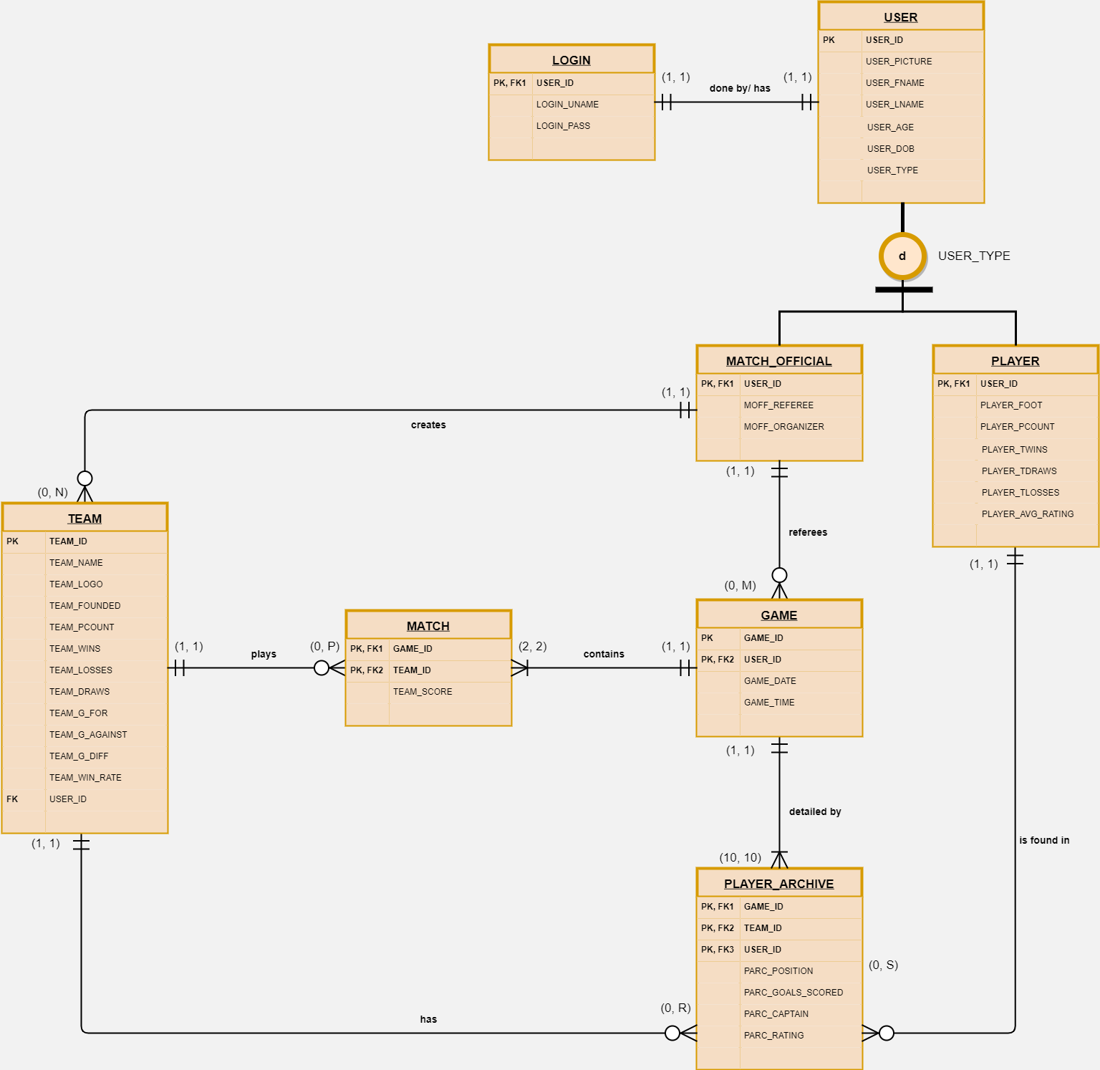

# Implementation

## Tables

ERD…

## Functions

## Procedures

## Views

WINNERS_LOSERS VIEW, DRAWN_GAMES VIEW

## Triggers